Smart Hospital Management Console System

🎯 Project Objective
Students must:
- Draw all 9 UML diagrams
- Design using SOLID + DDD principles
- Implement Console Application using:
  - ✅ ADO.NET
  - ✅ Entity Framework Core (.NET 9)
- Follow 3-Layer Architecture
- Connect to SQL Server database appdb

📌 SYSTEM OVERVIEW
The Smart Hospital Management System manages:
- Doctors
- Patients
- Appointments
- CRUD Operations (List + DB)
- Console Menu Interface

🏗 SYSTEM ARCHITECTURE
Presentation Layer → Console UI
Application Layer → BLL
Data Access Layer → ADO.NET + EF Core
Database → SQL Server (appdb)

📊 REQUIRED UML DIAGRAMS
(As per UML building blocks
0_UML - Building Blocks
)
Students MUST draw the following diagrams manually and upload:
workspace/diagram/

1)CLASS DIAGRAM

Classes:
- Doctor
- Patient
- Appointment (NEW – Added for better design)
- IPatientManager
- IDoctorManager
- PatientManager
- DoctorManager
- PatientsBLL
- DoctorsBLL
- HospitalDbContext (EF Core)

Relationships:
- Doctor (1) → (0..*) Patient
- Doctor (1) → (0..*) Appointment
- Patient (1) → (1) Doctor
- PatientManager implements IPatientManager
- DoctorManager implements IDoctorManager
- BLL depends on Managers
- DbContext depends on Entities

2) OBJECT DIAGRAM
Example Runtime Objects:
Doctor d1
DoctorId = 1
Name = "Dr. Sharma"
Patient p1
Name = "Rahul"
DoctorId = 1
Shows real-time object instances.

3) USE CASE DIAGRAM

Actors:
- Admin
- Receptionist

Use Cases:
- Add Doctor
- List Doctors
- Add Patient
- Edit Patient
- Delete Patient
- Find Patient
- View Reports

4)SEQUENCE DIAGRAM
Example: Add Patient to DB
User → Console
Console → PatientsBLL
PatientsBLL → PatientManager
PatientManager → SQL Server
SQL Server → PatientManager
PatientManager → BLL → Console → User

5)COLLABORATION DIAGRAM
Shows interaction among:
- Console UI
- PatientsBLL
- PatientManager
- SQL Server
Focus on message numbering instead of timeline.

6)ACTIVITY DIAGRAM
Example: Add Patient Flow
Start
→ Enter Details
→ Validate DoctorId
→ Save to DB
→ Display Success
→ End
Decision nodes included for:
- Doctor exists?
- Validation success?

7) STATECHART DIAGRAM
For Patient Entity
States:
Registered
→ Under Treatment
→ Recovered
→ Discharged
→ Archived
Transitions triggered by:
- Update condition
- Delete record

8)DEPLOYMENT DIAGRAM
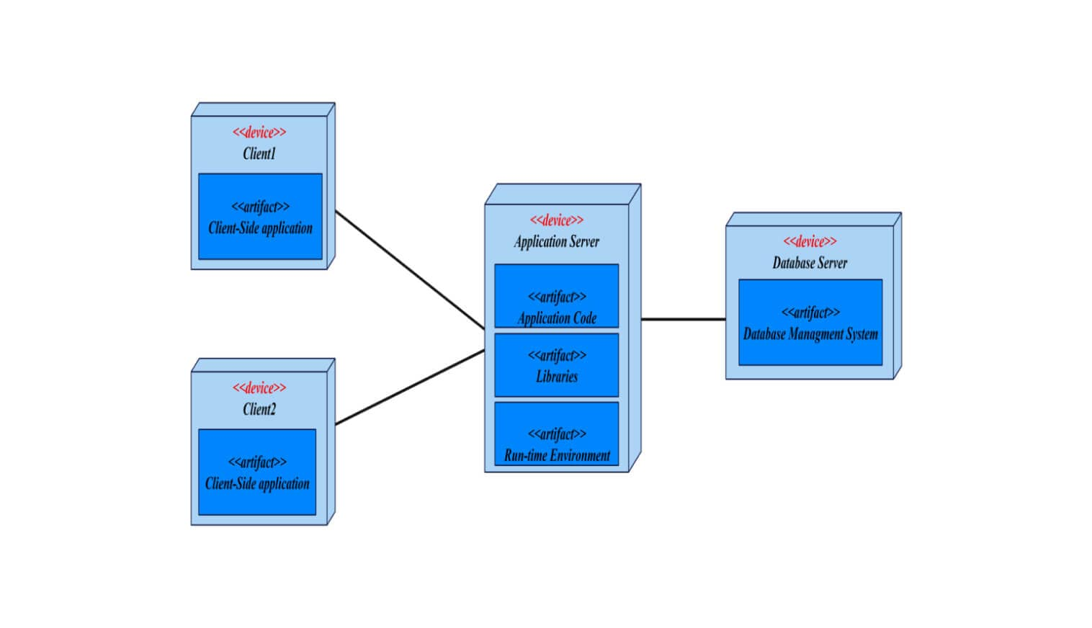

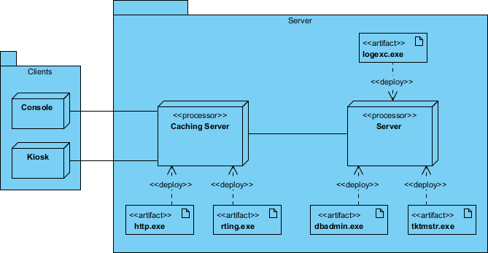
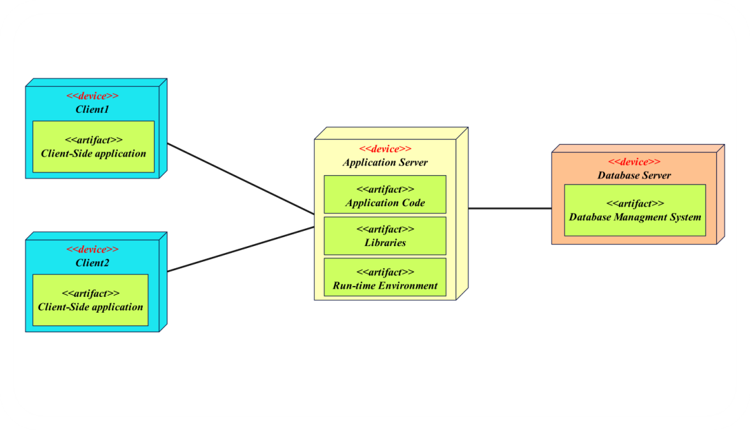
4
Nodes:
- Client Machine (Console App)
- Application Server (.NET Runtime)
- Database Server (SQL Server – appdb)

9)COMPONENT DIAGRAM
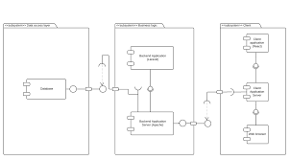
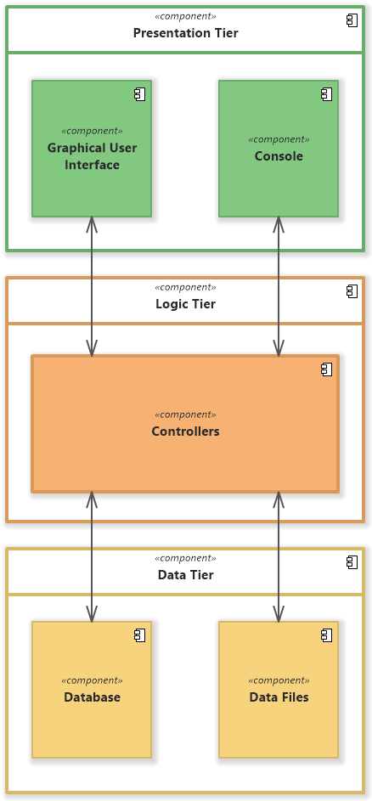

4
Components:
- Console UI
- BLL
- DAL (ADO.NET)
- DAL (Entity Framework)
- SQL Server

